

Project name:

EasyJob

Team name :

VP MASTERS

Team members [names]:

Valentin Petrov & Plamen Kostov

Link to the repositories [one or more]:

[https://github.com/PKKostov18/MusalaSoft-Project#documentation-and-presentation](https://github.com/PKKostov18/MusalaSoft-Project%23documentation-and-presentation)

Used technologies:

Teams, Visual Studio Code, GitHub, SSMS

Basic description of the project [purpose of the project]:

The goal of our project is to be able to make a website where people can find a job. Who needs a job to enter our site simply. As if everything is described there as salary conditions, etc.

Basic architecture of the project [details about different]:

Valentin deals with the front-end part, while Plamen Kostov deals with the back-end part. We also have a database system where we store account data.

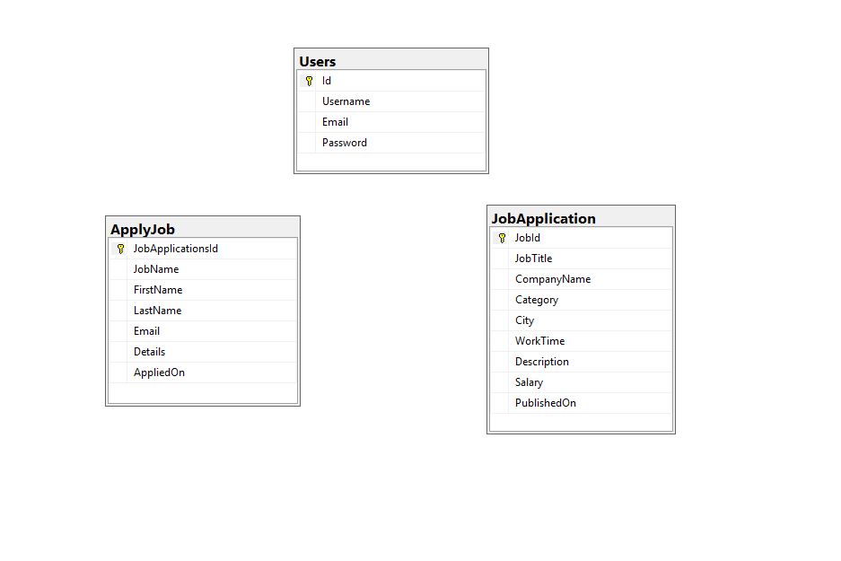

Link to the database script:

[https://github.com/PKKostov18/MusalaSoft-Project/blob/main/Database/databse.sql](https://github.com/PKKostov18/MusalaSoft-Project/blob/main/Database/databse.sql" \t "_blank)

Link to the readme file:

<https://github.com/PKKostov18/MusalaSoft-Project/blob/main/README.md>

Features: [describe different functionalities implemented in the project]:

What our site offers is the following. Home page you can then register if you do not have an account or log in if you already have one. As our data is stored in a database. You can then go in and consider some work that is right for you. We have a contact form that works. We also have my profile page, but it doesn't work because we didn't have enough time, but the design was made for it.